FB75 -

Functionality

The main source of the outgoing invoices / credit memos is the sales order billing document. The postings will be done in SD module. However, in some cases, it is possible to post the customer credit memo directly in Financial Accounting.

Scenario
A customer has found that he was overcharged on his invoice and has requested a credit memo be issued for the difference.

Requirements
Posted Customer Invoice.

Menu Path | Financial Accounting → Accounts Receivable → Document entry → FB75 - Credit memo
Transaction Code | FB75

1. Double click on FB75 - Credit memo.

Enter customer credit memo: Company code 5200

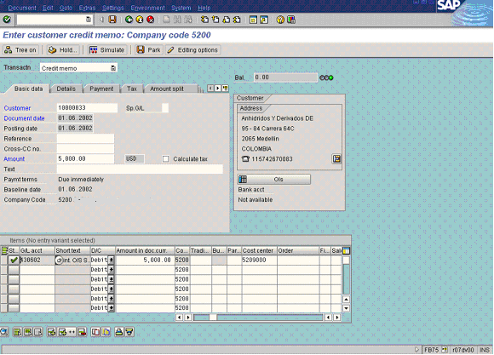

2. Update the following fields:

Field Name | Field Description | Values
Document date | Date the transaction occurred | Example: 21.05.2002
Amount | Amount of the credit memo | Example: 5600
G/L acct | Number of GL account | Example: 430001
Amount doc.curr. | Amount of the line item | Example: *
Cost center | Code identifying an organizational unit to which costs or assets are assigned | Example: 5209000

3. Click on the “Payment” tab:
Enter customer credit memo: Company code 5200

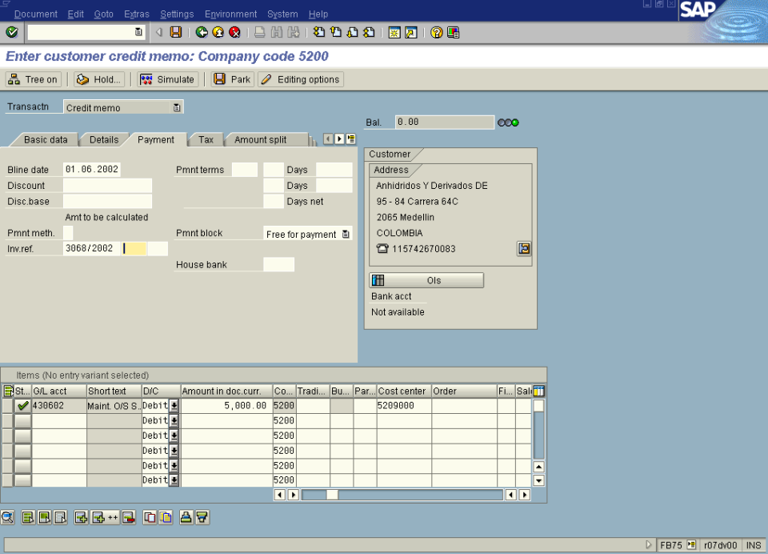

4. You need to enter a data regarding the original customer invoice, so you can track the purpose of the issuing credit memo later. Update the following field:

Field Name | Field Description | Values
Inv. Ref. | Number of the Invoice the Transaction Belongs to | Example: 3068/2002
5. To post the document click Save Button..

